
EAST WEST UNIVERSITY

Department of Computer Science and Engineering

Lab Reports

Submitted to:

- Syed Jamiul Alam

- Lecturer

- Department of Computer Science and Engineering

- East West University

Submitted by:
Name | Rakib Al Hasan
Student ID | 2024-1-60-143
Group | 09
Group members | Sumaiya Akter | 2023-3-60-579
 | Anjuman Ara | 2024-1-60-279
 | Rakib Al Hasan | 2024-1-60-143
Course Title | Electronic Circuits
Course Code | CSE 251
Section | 11
Semester | Fall 2025
Date of Submission | 06.12.2025


EAST WEST UNIVERSITY

Department of Computer Science and Engineering

Course code: CSE251; Course name: Electronic Circuits
Experiment No.: 01
Title: Verification of Ohm’s Law
Objectives:
- To experimentally verify Ohm’s Law
Introduction:
Ohm's law describes mathematically how voltage 'V', current 'I' and resistance 'R' in a circuit are related. According to this law.
"The current in a circuit is directly proportional to the applied voltage and inversely proportional to the circuit resistance".
Formula for voltage:
For a constant value of R, V is directly proportional to I i.e., V = IR
Formula for current: For a constant value of V, I is inversely proportional to R i.e.
I = V/R
Circuit Diagram:
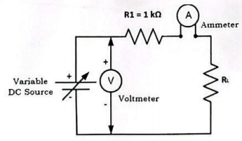

Figure: Circuit set up to verify Ohm’s Law.
Equipment s and Components Needed:
- Breadboard
- DC Variable Power Supply
- Resistor
- Connecting Wires
- Ammeter

Lab Procedure:
- Connect the Power Supply and ammeter in series.
- Now the resistance is adjusted to a fixed value (1kΩ) so that a constant current flows through the wires.
- Set the initial voltage as (0V) and note down the ammeter reading “I” across the circuit.
- Now increase the initial voltage as (1V) and note down the ammeter reading “I” again.
- The experiment is repeated for different values of voltages up to (10V) and the corresponding current values are noted.
- Calculate the value in each trial. These values will be found to be constants. Thus, verifying Ohm's law

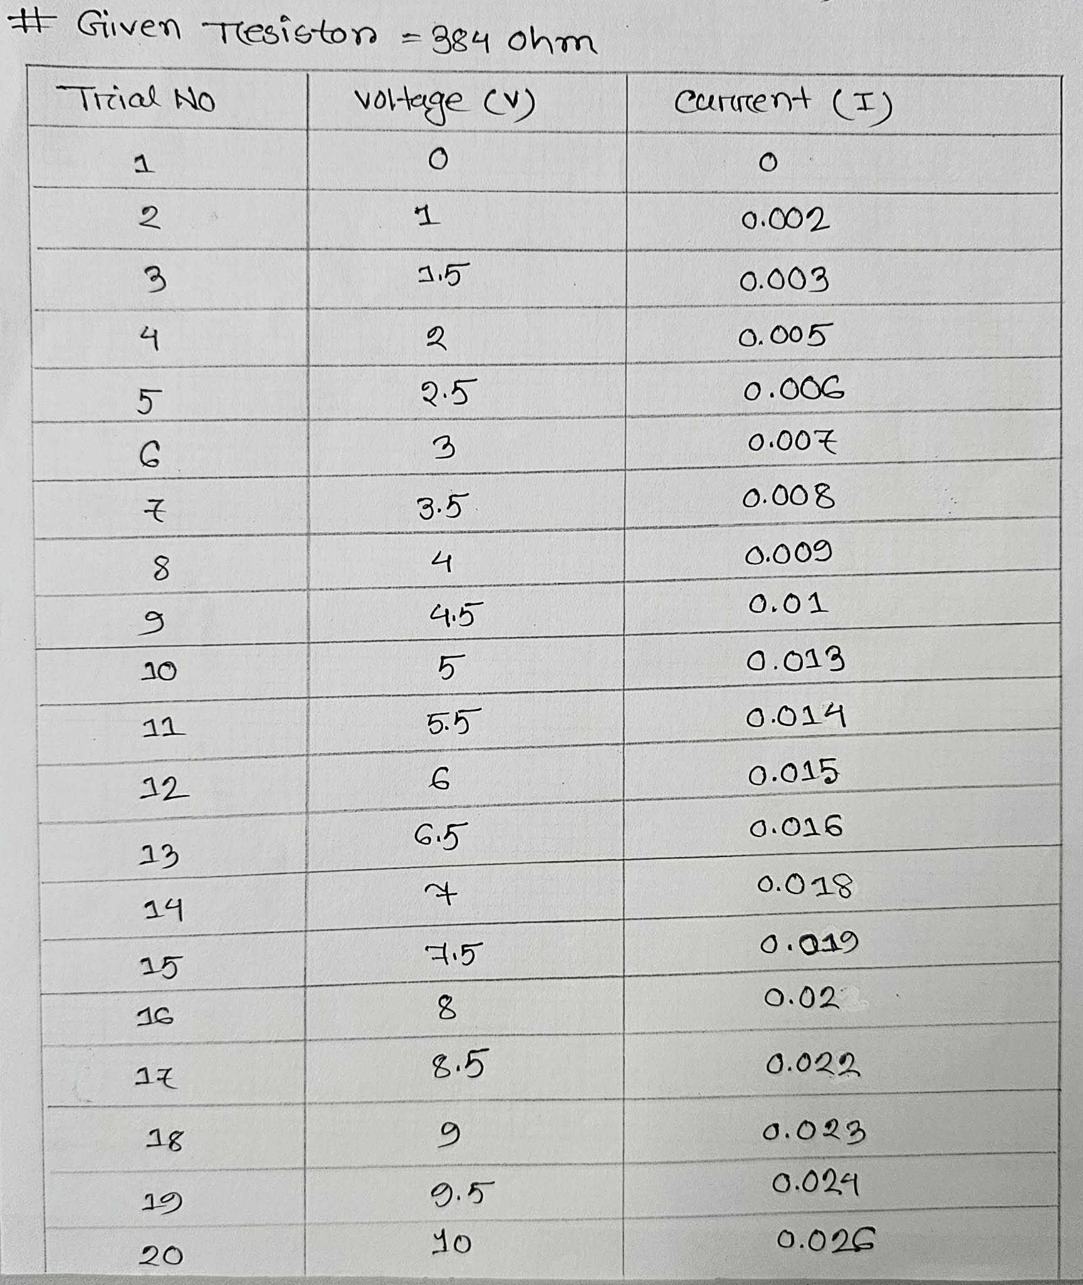
Table 1. Experimental Datasheet. (Given)

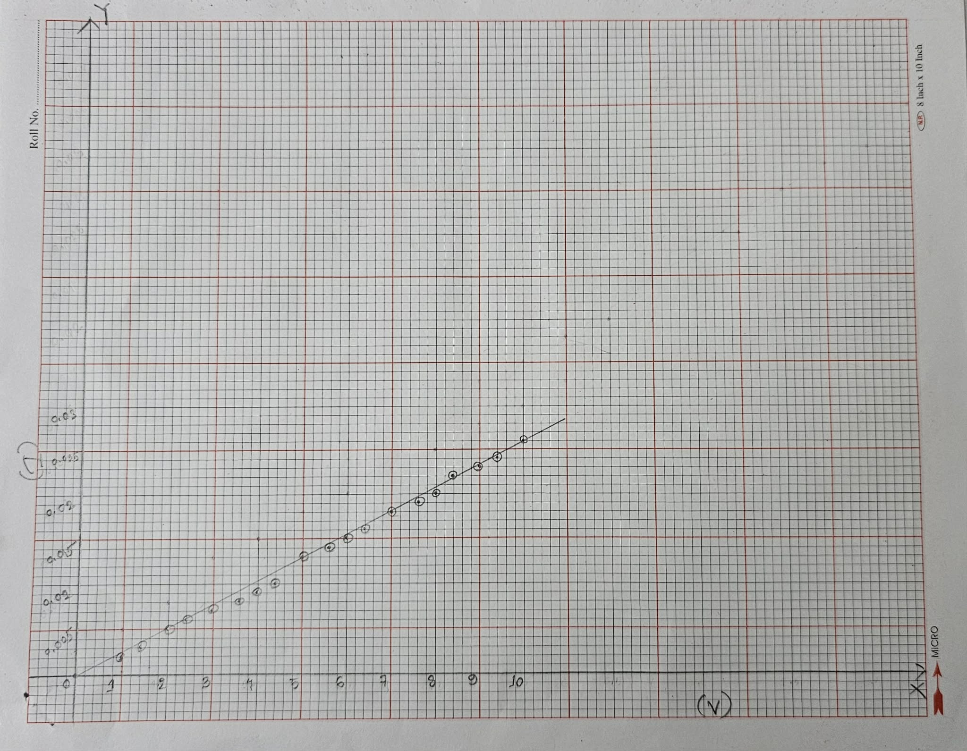

Table 1. Experimental Datasheet. (From our experiment)
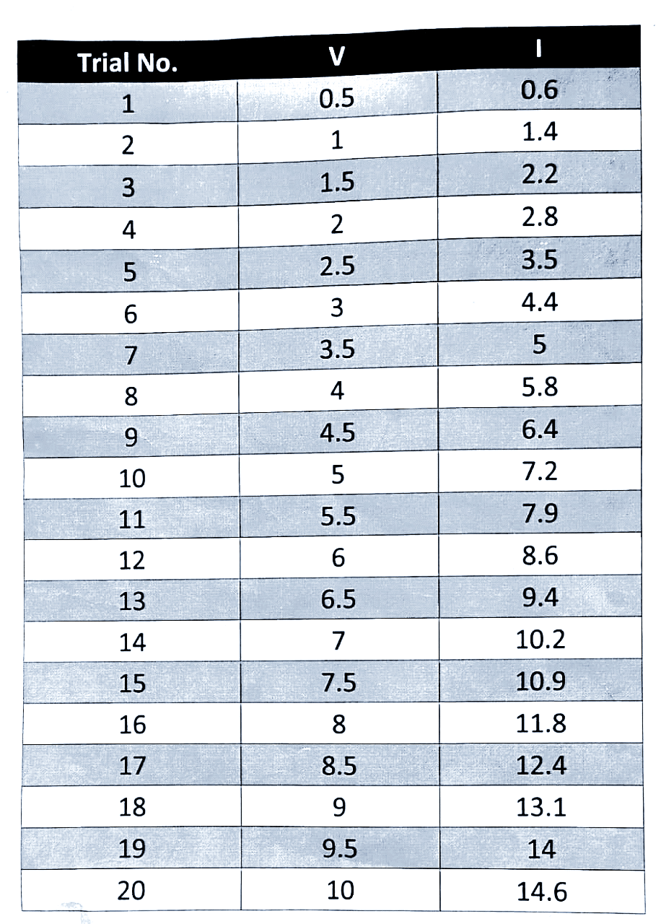
R=683Ω

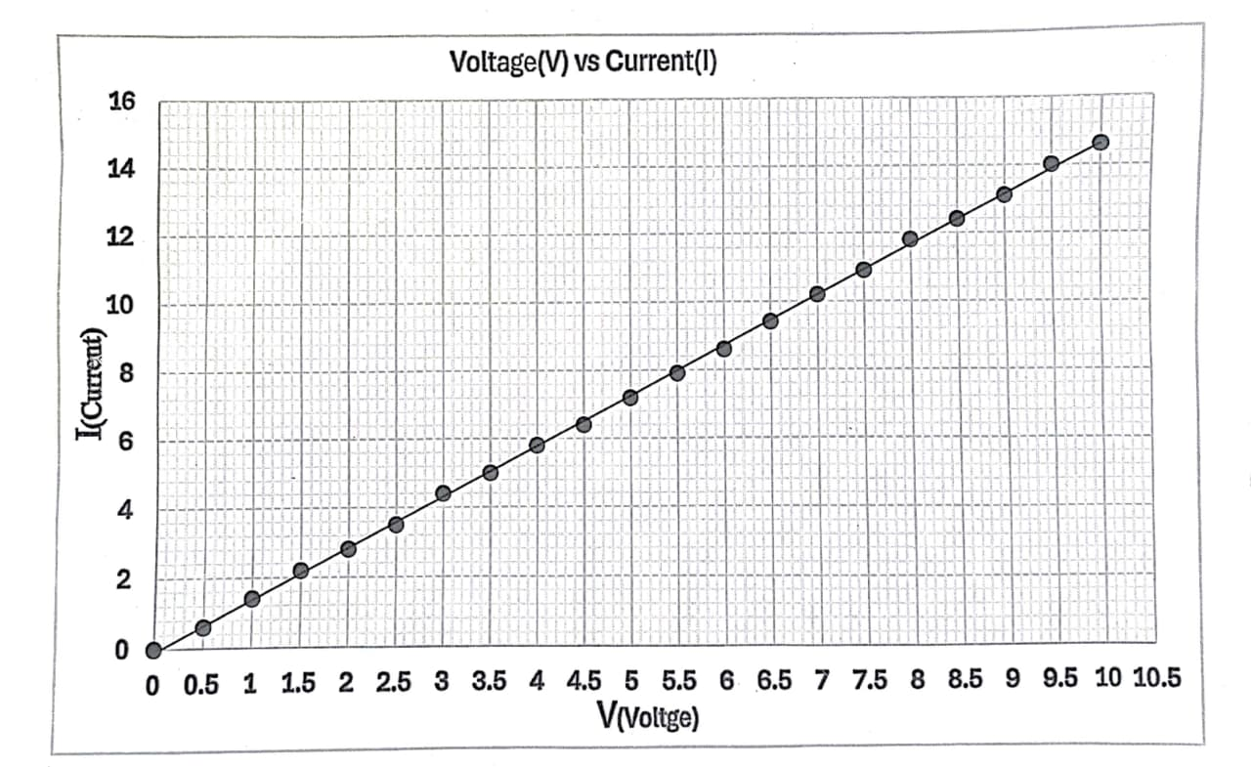


EAST WEST UNIVERSITY

Department of Computer Science and Engineering

Course code: CSE251; Course name: Electronic Circuits
Experiment No.: 02
Title: I-V Characteristics and Modeling of Forward Conduction of a Diode
Objectives:
- To measure the I-V characteristics of forward conduction of a p-n junction diode.
- To determine the models of forward conduction of a p-n junction diode.

Introduction:
Diode is one of the most basic non-linear electronic devices. An ideal diode acts like a switch for electric current, acting as a short circuit for current flow in one direction (forward bias connection) while behaving as an open circuit for current flow in the opposite direction (reverse bias connection). The characteristics of practical diodes are however somewhat different from those of ideal ones. The p-n junction diodes are one of the most popular types of diodes used in the industry. The forward bias current-voltage (I-V) characteristic of a p-n junction diode will be measured in this experiment.

Circuit Diagram:
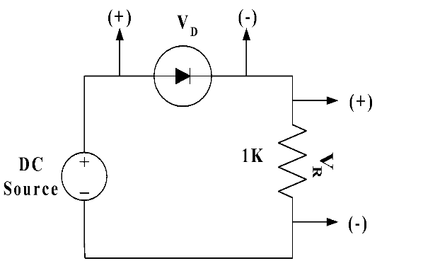

Figure 1. Circuit set up to measure forward bias I-V characteristics of a diode.
Equipment’s and Components Needed:
- DC power supply
- Digital multimeter
- Diode (1 pc)
- Resistor 1KΩ
- Breadboard
- Connecting wires

Lab Procedure:
- Measure the resistance value of Figure 1 with the multimeter and write it down in KΩ in Table 1.
- Connect the circuit as shown in Figure 1. Use the DC power supply unit as DC source.
- Change the DC source and measure the values of V_{D} and V_{R} and write them in Table 1. Continue measurement until V_{D} reaches to around 0.68 volts. Take around 25 to 30 readings by increasing the DC power supply with an increment of ≈ 0.5 V after V_{D} reaches to around 0.68 volts.
- Divide V_{R} by the measured value of resistance in KΩ. This is diode current I_{D} in mA.
- Have the datasheet signed by your instructor.

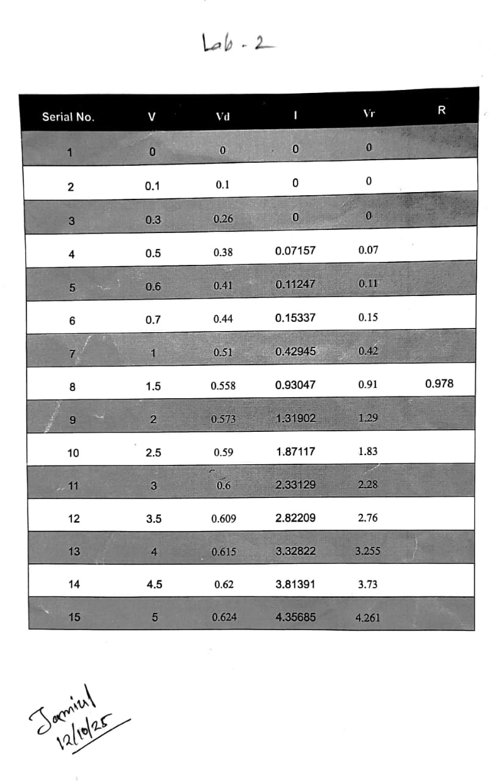
Table 1. Experimental Datasheet.

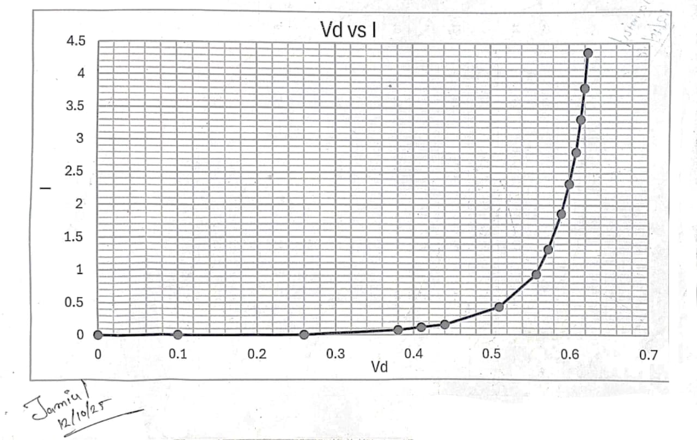

Post-Lab Report Questions:
- Using MATLAB, plot the I-V characteristics of the p-n junction diode in forward conduction. Label the axes appropriately and have it printed.
- Use pencil to identify the points on your graph that are corresponding to I_{D} = 2 mA and I_{D} = 2.5 mA. Use these data points to calculate the diode parameters $I_{S}$ and $n$ from the equation${ I}_{D}=I_{S}e^{\left[\frac{V_{D}}{nV_{T}}\right]}$
Use V_{T} = 0.0259V.
Answer:
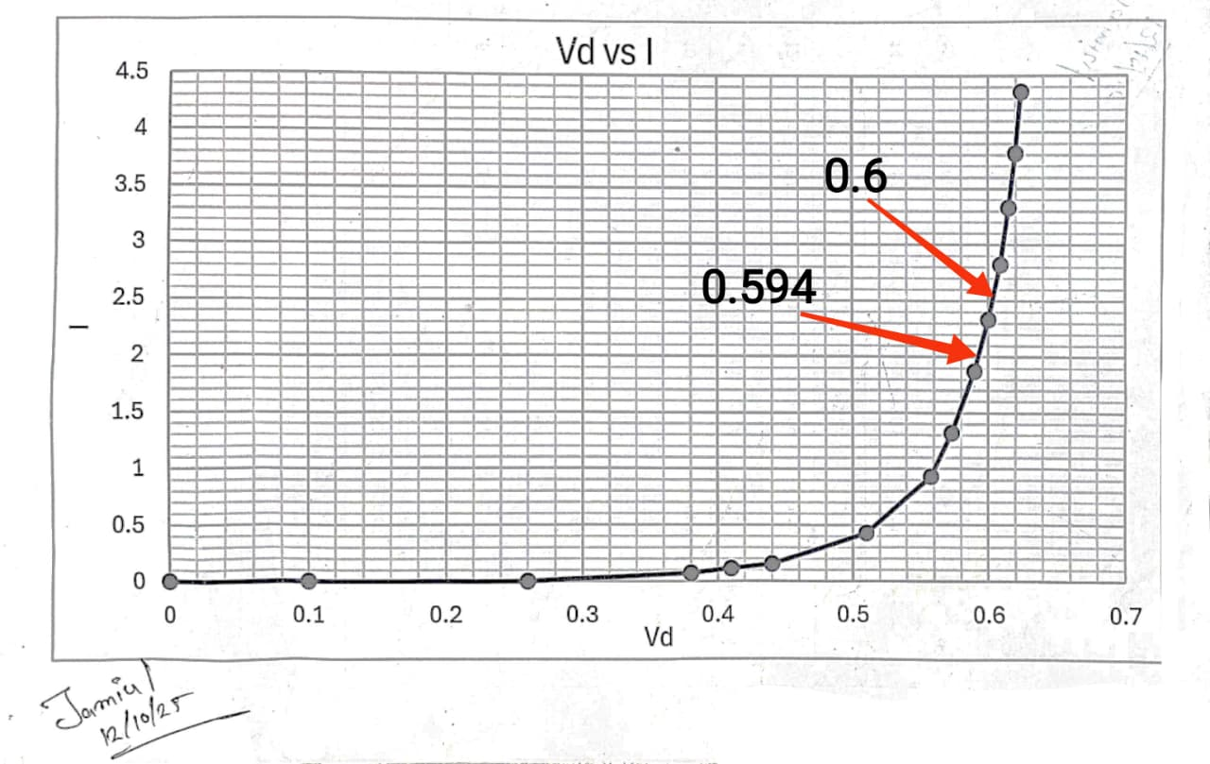

$$For, I_{D1}=2 mA , V_{D1}=0.594V$$
$$I_{D2}=2.5 mA, V_{D2}=0.6V$$
$$լNow,$$
$$V_{D2}-V_{D1}=nV_{T}\ln\left[\frac{I_{D2}}{I_{D1}}\right]$$
$$n= \frac{V_{D2}-V_{D1}}{V_{T}×ln\left[\frac{I_{D2}}{I_{D1}}\right]}$$
$$n=\frac{0.6-0.594}{0.0259×\ln\left[\frac{2.5}{2}\right]}$$
$$∴n=1.04$$

$$Again,$$
$$For , I_{D}=2 mA$$
$${ I}_{D}=I_{S}e^{\left[\frac{V_{D1}}{nV_{T}}\right]}$$
$$I_{S}=\frac{I_{D}}{e^{\left[\frac{V_{D1}}{nV_{T}}\right]}}$$
$$I_{S}=\frac{2×{10}^{-3}}{ e^{\left[\frac{0,594}{1.04×0.0259}\right]}}$$
$$I_{S}=5.295×{10}^{-10} mA$$

$$For, I_{D}=2.5 mA$$
$${ I}_{D}=I_{S}e^{\left[\frac{V_{D2}}{nV_{T}}\right]}$$
$$I_{S}=\frac{I_{D}}{e^{\left[\frac{V_{D2}}{nV_{T}}\right]}}$$
$$I_{S}=\frac{2.5×{10}^{-3}}{ e^{\left[\frac{0,6}{1.04×0.0259}\right]}}$$
$$I_{S}=5.297×{10}^{-10} mA$$

- Determine the cut-in voltage from the printed graph by drawing an extrapolated line with pencil.
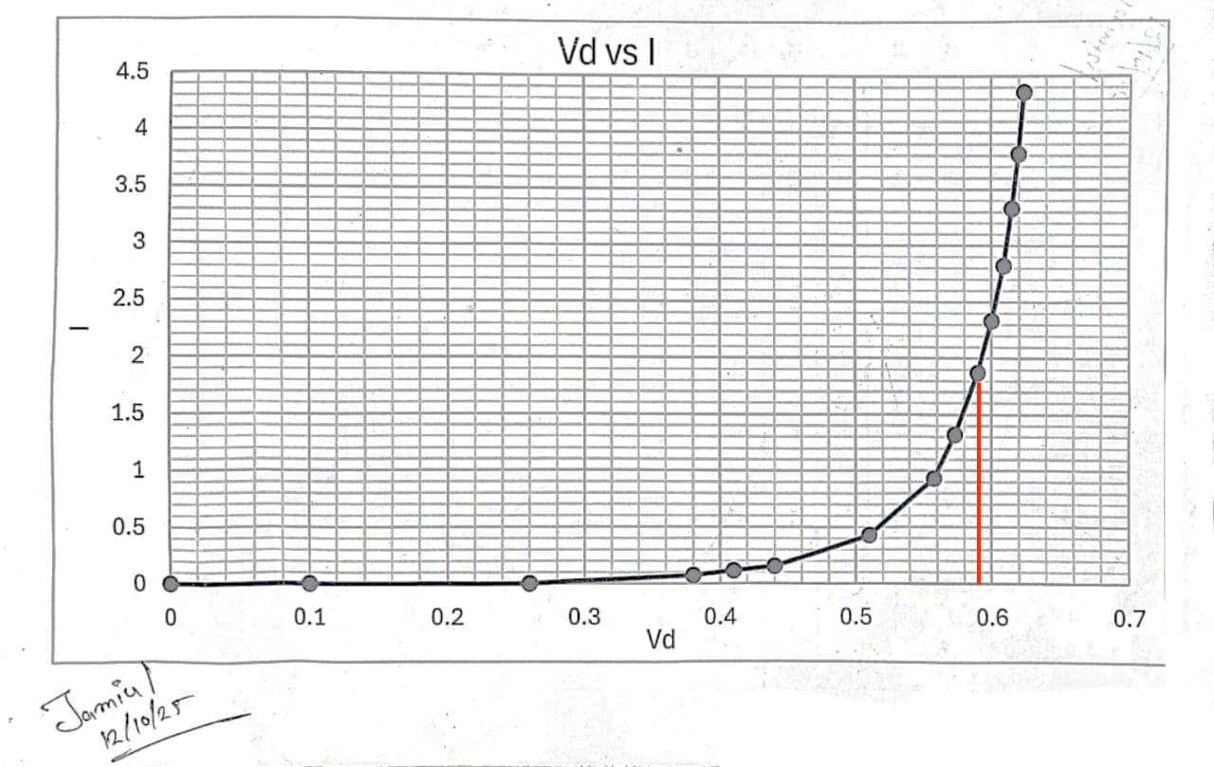
Answer:

From the above graph, we can see, the cut-in voltage is around 0.59
- If the diode resistance for the piecewise linear model is defined as
$\frac{1}{r_{D}}=\frac{∂I_{D}}{V_{D}}∂=\frac{\left(I_{D2}-I_{D1}\right)}{\left(V_{D2}-V_{D1}\right)}$, calculate the value of $r_{D}$ from the data points corresponding to I_{D} = 2 mA and I_{D} = 2.5 mA.

Answer:
Here,
$$I_{D1}=2 mA , V_{D1}=0.586V$$
$$I_{D2}=2.5 mA, V_{D2}=0.6V$$

We know,
$$\frac{1}{r_{D}}=\frac{∂I_{D}}{V_{D}}∂=\frac{\left(I_{D2}-I_{D1}\right)}{\left(V_{D2}-V_{D1}\right)}$$
$$r_{D}=\frac{V_{D2}-V_{D1} }{I_{D2}-I_{D1}}$$
$$r_{D}=\frac{0.6-0.586 }{2.5-2}$$
$r_{D}=$ 28Ω

- Simulate the circuit of Figure 1 for a DC bias (V_{S}) range of 0-5 volts using PSpice. Print the I_{D} vs. V_{S} and V_{D} vs. V_{S} plots generated by PSpice and attach them with your report. For simulation, use the DC SWEEP option of PSpice and the diode D1N4148. To modify the diode parameters, select the diode (it will turn red) and go to Edit→Model→Edit Instance Model (Text). There, replace the values of I_{S}, N, V_{j} by your values calculated in steps 2 and 3 and click OK.


EAST WEST UNIVERSITY

Department of Computer Science and Engineering

Course: CSE251 Electronic Circuits
Experiment No.: 03
Title: Half-Wave Diode Rectifier Circuit
Objectives:
- To study half-wave diode rectifier circuits.
- To study the effect of a capacitor filter on the output of the rectifier circuit.

Introduction:
A rectifier circuit converts an AC voltage with zero average into a unidirectional voltage with a non-zero average. The rectifier circuit can rectify both positive and negative half-cycles (full-wave rectifier) or only the positive half-cycle (half-wave rectifier) of a sine wave. A capacitor connected across the load resistor acts as a filter and reduces the ripple of the output voltage. The time constant of the RC network should be much larger than the period of the AC source voltage for effective filtering.

Circuit Diagram:
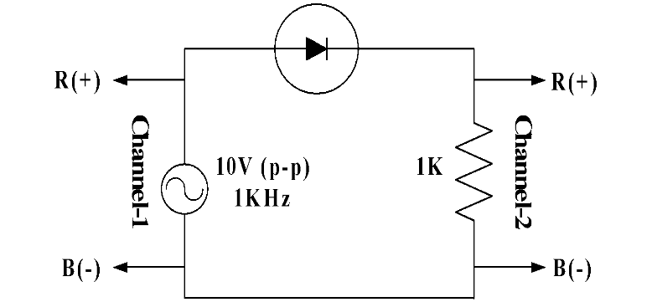

Figure 1. Set up for a half-wave diode rectifier circuit.

Equipments and Components Needed:
- Signal Generator
- Digital multimeter
- Diode (1 pc)
- Resistor 1KΩ (1 pc)
- Capacitor 10μF (1 pc)
- Breadboard
- Connecting wires

Pre-Lab Report Question:
- Consider the half-wave rectifier circuit shown in Figure 1. It is fed by a 1.0 KHz sinusoid having a peak value of 5V. Design the circuit (determine the value of the parallel capacitor) so that the output will have a peak-to-peak ripple of 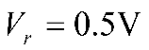 using the formula 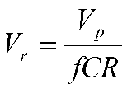. Calculate the diode conduction time and conduction angle using the formula 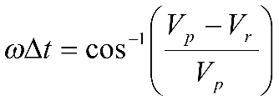. Also calculate the average and peak values of the diode currents using the formulas 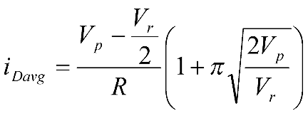and 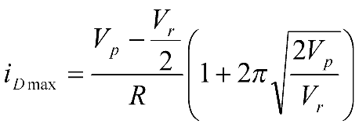.

Lab Procedure:
- Measure the resistance and write it down.
- Setup the circuit shown in Figure 1.
- Setup a 10 volts peak-to-peak, 1 KHz sine wave signal from the signal generator and observe it in channel-1 of the oscilloscope.
- Give input to the circuit and observe the output in channel-2 of the oscilloscope.
- Observe both the input (in channel-1) and the output (in channel-2) signals by setting dual mode in the oscilloscope.
- Measure the difference in peak values (ΔV_{p}) between the input and the output, and write it down.
- Connect the capacitor from your design in the pre-lab report in parallel with the resistance and observe the output only.
- Measure the time (Δt) during which the diode conducts (time between the lower peak to the upper peak of the ripple voltage, that is, the time of charging the capacitor) and write it down.
- Measure the peak-to-peak ripple voltage (V_{r}) from the oscilloscope and write it down.
- Measure the average value of output voltage (V_{O}) using the DC mode of the multimeter and write it down.
- Have the datasheet signed by your instructor.

Post-Lab Report Questions:
- Compare the measured value of ΔV_{p} with the built-in voltage of Expt 1.
Answer:
Measure value of ΔV_{p} of Experiment-1
$$ΔVp = 10.8V-9.44V=1.36V$$
Which is close to the Δ𝑉 = 0.7 V for silicon diode
Comparison table:
Measure value of ΔV_{p} | Built-in voltage of silicon diode | Discrepancy
1.36 V | 0.7 V | 94.286%

- Compare your measured Δt with your prelab value and make a comment.
Answer:
$$Given values,$$
$$V_{p}=5 V$$
$$V_{r}=0.5 V$$
$$f=1000 Hz$$
$$We know,$$
$$ω=2πf=2π×1000=6283.185 rad/s$$
$$ω (Δt)=cos\left( \frac{V_{p}-V_{r}}{V_{p}}\right)=cos\left( \frac{5-0.5}{5}\right)=0.451 rad$$
$$Then,$$
$$∴prelab value of Δt=\frac{0.451}{ω}=\frac{0.451}{6283.185}=71.78 μs$$
$$And ,Measured value of Δt=117.3 μs$$

Comparison table:
Pre-lab Value  (Calculated) | Experimental Value of $Δt$ | Discrepancy
71.78 μs | 117.3 μs | 63.416%
- Calculate the peak-to-peak ripple voltage from the formula 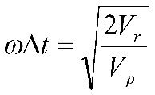 and compare it with your measured data and prelab data and make a comment.
Answer:
$$Given values,$$
$$V_{p}=5 V$$
$$V_{r}=0.5 V$$
$$f=1KH_{Z}=1000 Hz$$
$$Δt=117.3 μs$$
$$We know,$$
$$ω=2πf=2π×1000=6283.185 rad/s$$
$$ω \left(Δt\right)=\sqrt{\frac{2V_{r}}{V_{P}}}$$
$${∴V}_{r}={\left[ω \left(Δt\right)\right]}^{2}×\frac{V_{P}}{2}={(6283.185×117.3×{10}^{10-6} )}^{2}×\frac{5}{2}=1.36V$$
$$And ,Measured value of V_{r}=2.45V$$

Comparison table:
Pre-lab Value of $V_{r}$ | Experimental Value of $V_{r}$ | Calculated Value of $V_{r}$
0.5 | 2.45V | 1.36V

- Calculate the average output voltage from 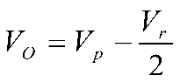 and compare it with the measurement.
Answer:
$$Given values,$$
$$V_{p}=5 V$$
$$V_{r}=2.45 V$$
$${∴Calculated Value of V}_{0}=V_{P}-\frac{V_{r}}{2}=5-\frac{2.45}{2}=3.775 V$$
$$And ,Measured value of V_{0}=3V$$

Comparison table:
Pre-lab Value  (Calculated) | Experimental Value of $V_{0}$ | Discrepancy
3.775V | 3V | 20.53%

- With 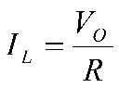, calculate the average and maximum diode currents using the formulas 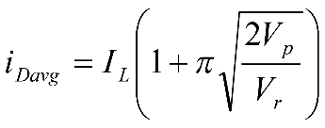 and 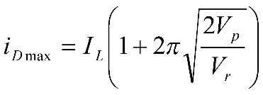 and measured the value of V_{r} and compared it with your pre-lab values and made a comment.
Answer:
$$The measured value of$$
$$V_{r}=2.45 V$$
$$V_{0} = 3 V$$
$$Given value,$$
$$V_{P}=5V$$
$$I_{L}=\frac{V_{0}}{R}=\frac{3}{1000}=3×{10}^{-3}A$$

$$Then, the calculation value from the experiment,$$
$$The average diode current,$$
$$I_{D avg}=I_{L}×\left(1+π\sqrt{\frac{2V_{P}}{V_{r}}}\right)=3×{10}^{-3}×\left(1+π\sqrt{\frac{2×5}{2.45}}\right)=0.022A$$
$$The maximum diode current,$$
$$i_{D max}=I_{L}×\left(1+2π\sqrt{\frac{2V_{P}}{V_{r}}}\right)=3×{10}^{-3}×\left(1+2π\sqrt{\frac{2×5}{2.45}}\right)=0.041A$$

$$The calculation value from the Pre-lab,$$
$$V_{r}=0.5 V$$
$${∴ V}_{0}=V_{P}-\frac{V_{r}}{2}=5-\frac{.5}{2}=4.75 V$$
$$I_{L}=\frac{V_{0}}{R}=\frac{4.75}{1000}=4.75×{10}^{-3}A$$
$$The average diode current,$$
$$I_{D avg}=I_{L}×\left(1+π\sqrt{\frac{2V_{P}}{V_{r}}}\right)=4.75×{10}^{-3}×\left(1+π\sqrt{\frac{2×5}{0.5}}\right)=0.0715A$$
$$The maximum diode current,$$
$$i_{D max}=I_{L}×\left(1+2π\sqrt{\frac{2V_{P}}{V_{r}}}\right)=3×{10}^{-3}×\left(1+2π\sqrt{\frac{2×5}{0.5}}\right)=0.1382A$$
Comparison table:
 | Pre-lab Value | Experimental Value | Discrepancy
$$I_{L}$$ | $$4.75×{10}^{-3}A$$ | $$3×{10}^{-3}A$$ | 36.84%
$$V_{r}$$ | $$0.5 V$$ | $$2.45 V$$ | 390%
$$i_{D max}$$ | $$0.1382A$$ | $$0.041A$$ | 70.33%
$$I_{D avg}$$ | $$0.0715A$$ | $$0.022A$$ | 69.23%

- Simulate the half-wave rectifier circuit in PSPICE for C = 10 μF and submit the input and output plots (on the same graph). Use transient analysis of PSPICE for 4 cycles of input (4 ms). Modify the diode parameters following the same procedure and the same parameters values used in Expt 1.
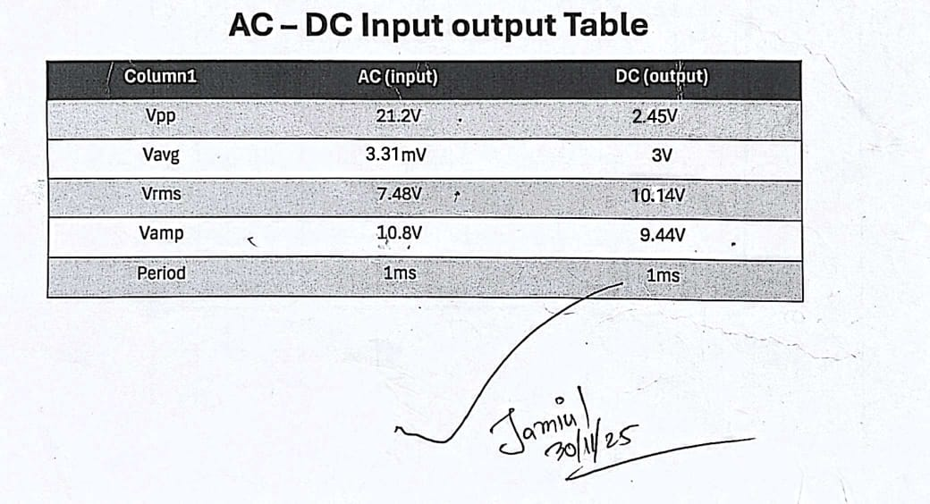

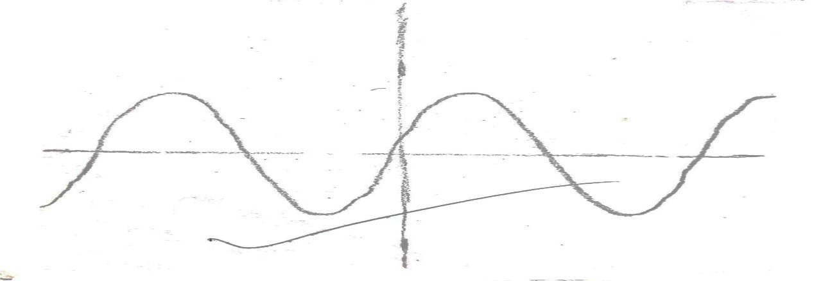

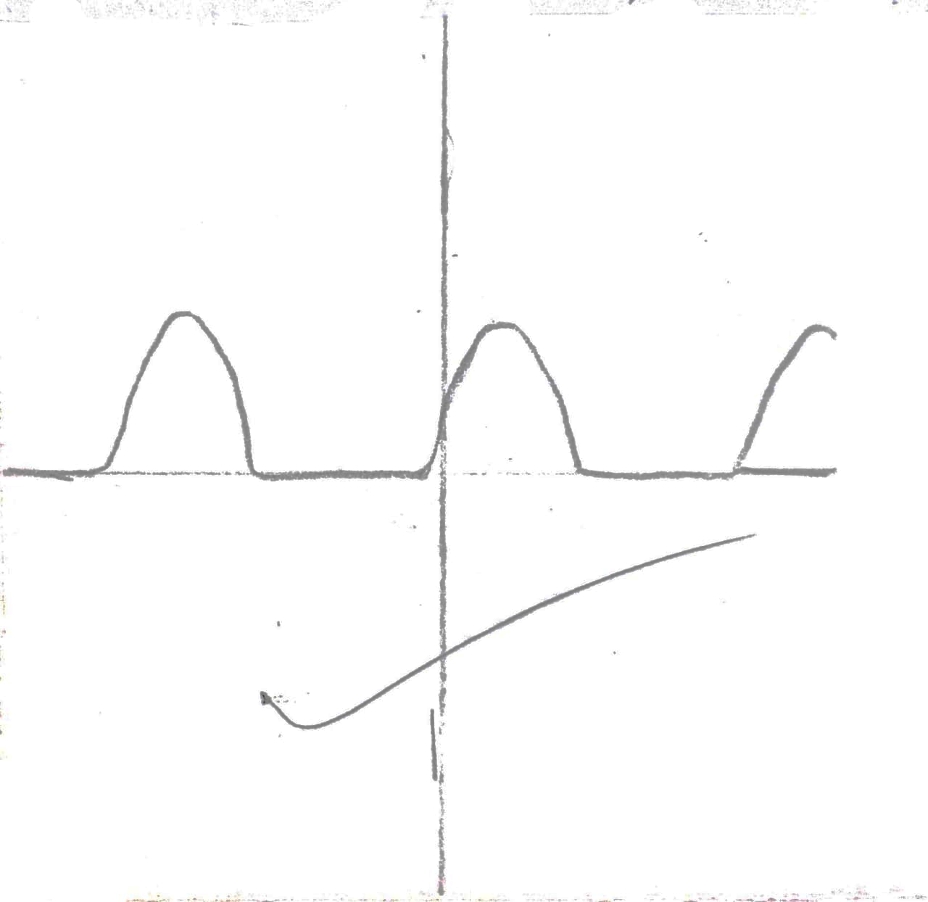

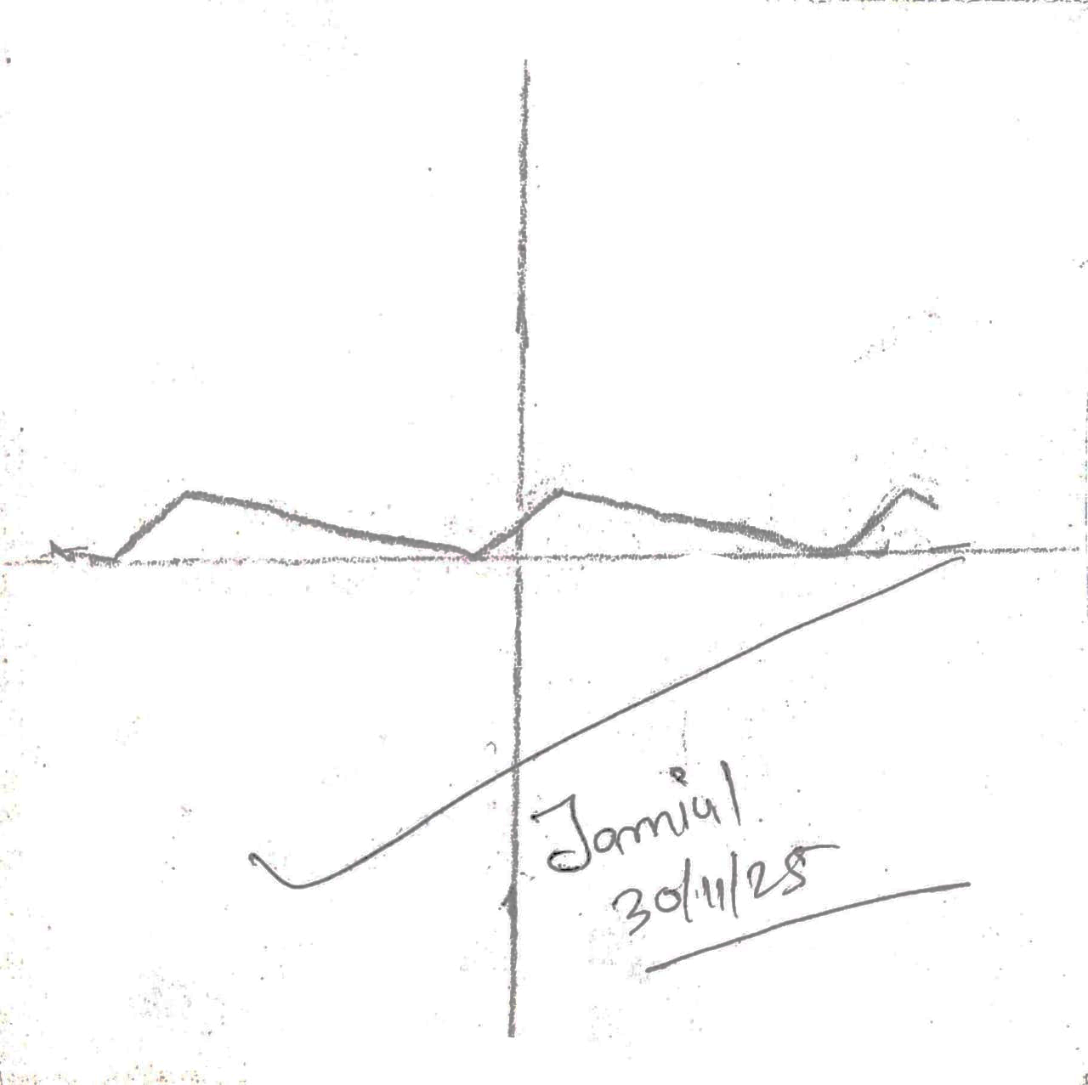


EAST WEST UNIVERSITY

Department of Computer Science and Engineering

Course: CSE251 Electronic Circuits
Experiment No.: 04
Title: Study of Zener Diode.
Objectives:
- To measure the I-V characteristics of Zener diodes.
- To determine the voltage regulation for variable resistance and variable supply voltage.

Introduction:
The diodes we have studied before do not operate in the breakdown region because this may damage them. A Zener diode is different; it is a silicon diode that the manufacturer has optimized for operation in the breakdown region. It is used to build voltage regulator circuits that hold the load voltage almost constant despite large change in line voltage and load resistance. Figure shows the symbol of the Zener diode.

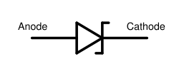

Fig.1: Symbol of Zener diode

The Zener diode may have a breakdown voltage from about 2 to 200 V. These diodes can operate in any of the three regions: forward, leakage and breakdown. The figure shows the 1-V graph of the Zener diode.

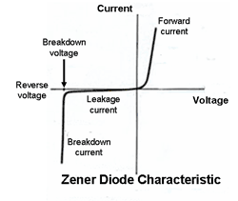

Fig. 2: I-V characteristic curve

- In the forward region it works as an ordinary diode.
- In the leakage region (between zero and breakdown) it has only a small reverse saturation current.
- In the breakdown it has a sharp knee, followed by an almost vertical increase in current
without changing the voltage.
- The voltage is almost constant, approximately equal to Vz over most of the breakdown
region.

Approximation:
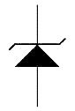


“On” [V V_{z} ] “Off” [V_{z} >V > 0]

Pre-Lab Report:
- Draw the I-V characteristic of Fig. 3 (circuit with no load) and
- calculate V_{L,} V_{R,} I_{Z} for 10 V supply voltage.
- Consider R_{L} = 220 Ω and write down the condition for conduction.
- Calculate R_{Lmin}, R_{Lmax}, I_{Lmin} for I_{Lmax} for I_{zmax}= 7.2mA and 10 V supply voltage in Fig. 4.
- Calculate V_{imin}, and V_{imax} for I_{zmax}= 7.2mA of Fig. 5.

Equipments:
- Zener diode (6.2 volt)
- Resistance (220 Ω, 470 Ω, 1 kΩ)
- POT 10 kΩ
- DC Power supply
- Bread board
- Multimeter.
- Ammeter.

Experimental Setup:

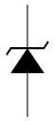

+ V - + V -
Ω
470
V
6.2

220
Ω
V
L
Ω
470
V
6.2
V
i
= 10V
V
i
= 10V
R
v
R
R

Fig. 3: Circuit with No Load Fig. 4: Circuit with variable load


+ V_{R} -

Ω
470
6.2
V
1
KΩ

V
L

V
i

Fig. 5: Circuit with variable supply voltage.

Procedure:
- Connect the circuit as shown in Figure 3.
- Vary the supply voltage from zero to 10 volts and complete Table 1.
- Now, connect the circuit as shown in figure 4.
- Keep the POT (variable resistance R_{s}) at its maximum value which you have calculated from pre lab.
- Gradually decrease the POT resistance up to minimum R_{s} which you have calculated from pre lab, next calculate I_{L} by ohm’s law.
- complete Table 2.
- Replace load with 1 kΩ resistance, vary the supply voltage V_{i and} complete

Experimental Datasheet.
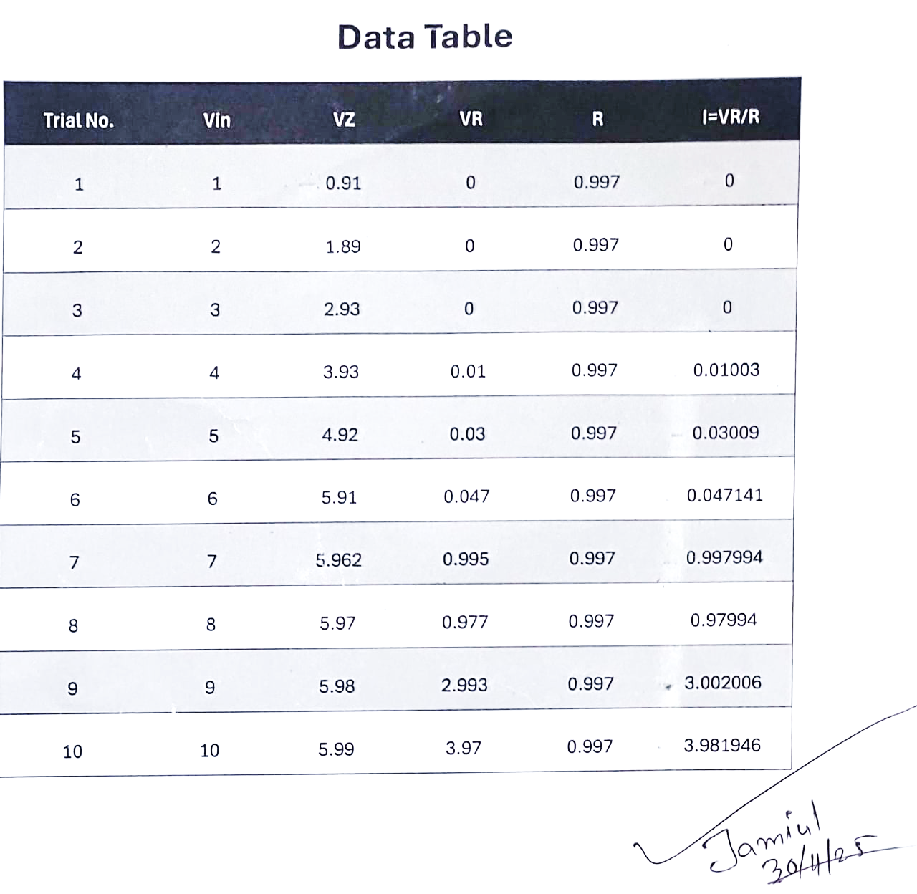

Table 1: Data for I-V characteristics
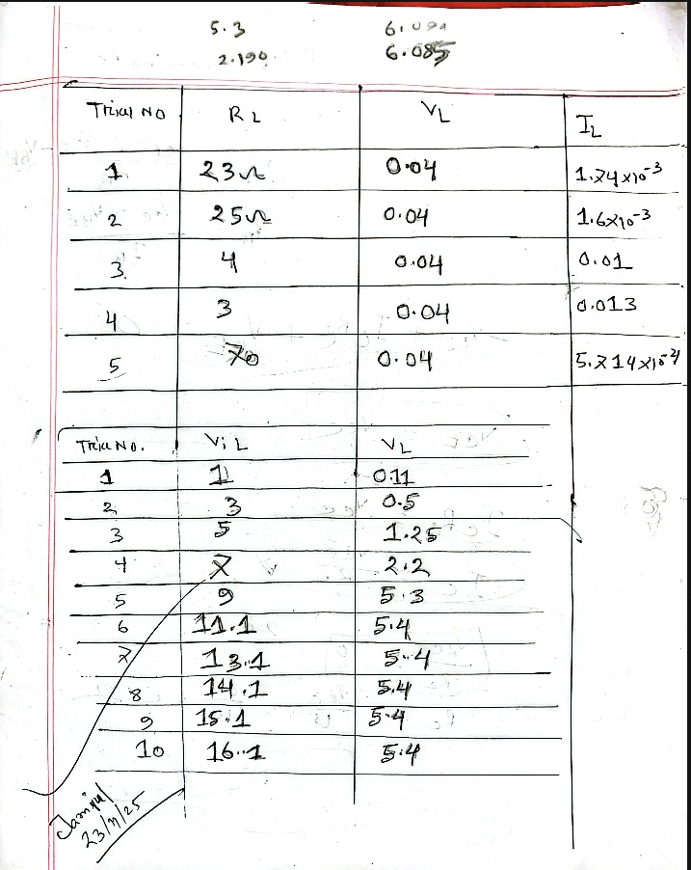

Table 2: Data for regulation due to load variation
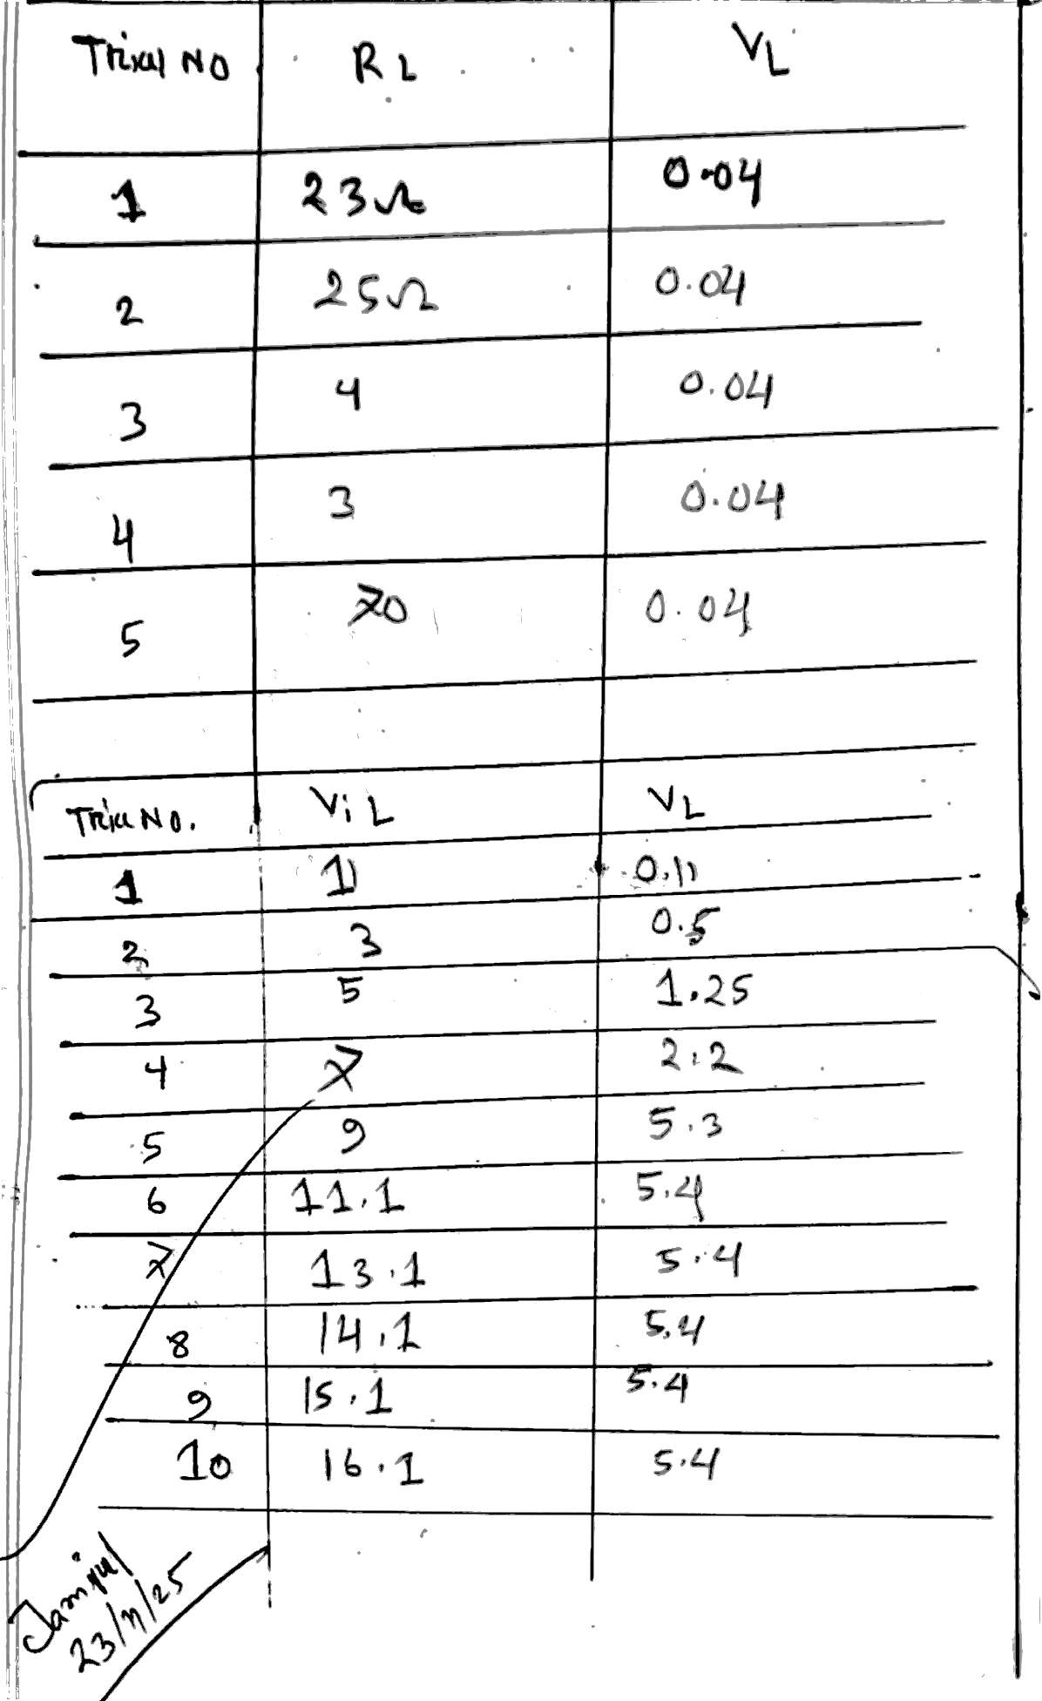

Table 3: Data for regulation due to supply voltage variation
Post Lab Report Questions:
      - Plot the I-V characteristics of the Zener diode. Determine the Zener breakdown voltage from the plot.
Answer:
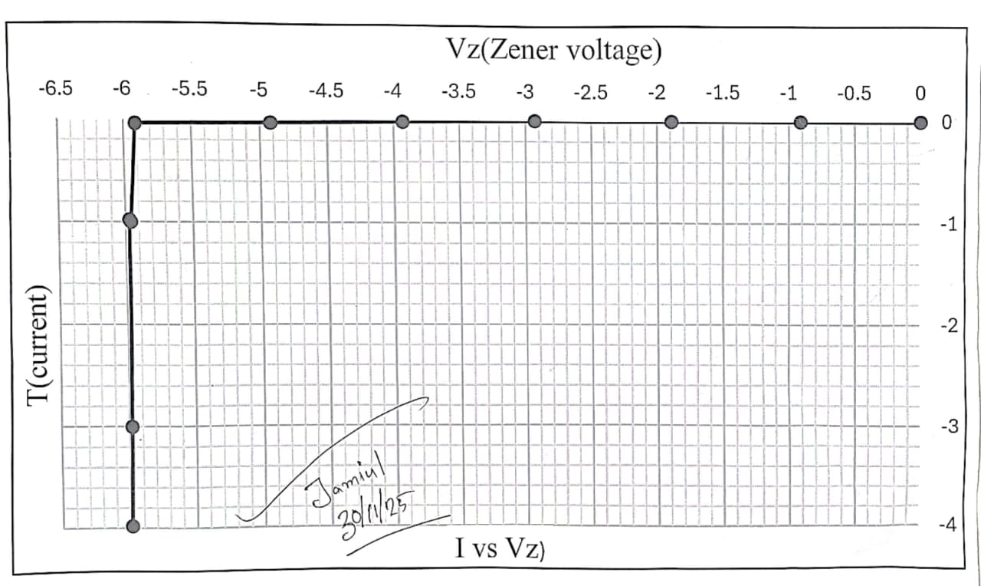

The Zener diode enters full breakdown at around 5.9V.

      - Plot I_{L} Vs V_{L} for the data of table-2. Find the load regulation and compare it with the pre-lab data.
Answer:
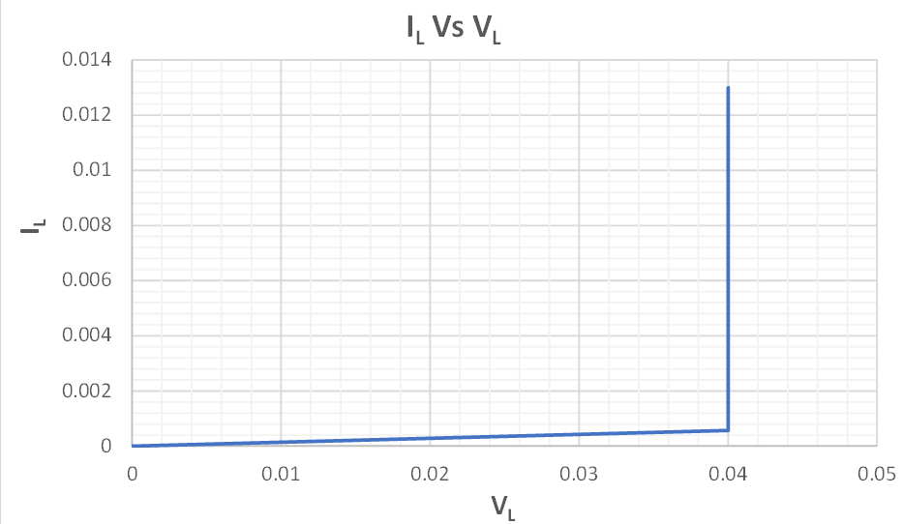

$$Load Regulation \left(LR\right)quantifies how well a voltage regulator maintains$$
$$a constant output voltage \left(V\right)despite changes in load current \left(I\right).$$
$$It is calculated using the formula:$$
$$Load Regulation = \frac{ V_{NL}-V_{FL}}{V_{FL}}×100\%$$
$$Where:$$
$$V_{NL} = No-Load Voltage (output voltage at minimum load current)$$
$$V = Full-Load Voltage (output voltage at maximum load current)$$

$$From the table,$$
$$V_{NL}=0.4V$$
$$V_{FL}=0.4 V$$
$$Load Regulation = \frac{ V_{NL}-V_{FL}}{V_{FL}}×100\%= \frac{ 0.4-0.4}{0.4}×100\%=0\%$$

Parameter | Experimental Result | Typical Theoretical Result
Regulated Voltage (VL) | 0.04 | 6.2
Load Regulation (%LR) | 0% | 0%
      - Plot V_{L} Vs V for the data of table 3. Find the line regulation and compare it with the pre-lab data.
Answer:
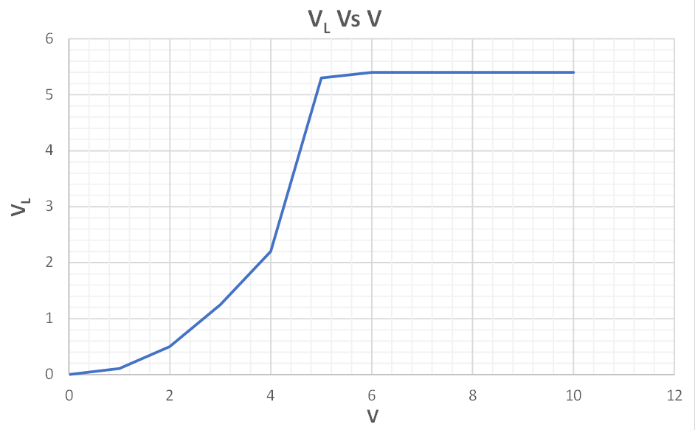

From the table,
$$V_{Lmax}=5.4V$$
$$V_{Lmin}=5.3V$$
$Now,$
$$ΔV_{L}=V_{Lmax}-V_{Lmin}=5.4-5.3=0.1V$$

$$Again,$$
$$V_{imax}=16.1V$$
$$V_{imin}=9V$$
${ΔV}_{i}= V_{imax}-V_{imin}=(16.1-9)V=7.1V$

$Line Regulation = \frac{ΔV_{L}}{{ΔV}_{i}}= \frac{0.1}{7.1}=0.0141\frac{V}{V}=14 mV/V$

$$From pre-lab,$$
$$V_{i}=10 V$$
$$V_{L}=6.2 V$$
$$Line Regulation = \frac{6.2}{10} =0.62 V/V=62 mV/V$$
$$Difference = (62-14) mV/V=48 mV$$

